

Pharmacy Management System

Project done by:
Suchinton Chakravarty
Badri M. S. V

Acknowledgements:

It is our privilege to express our sincerest regards to our respected principal, Miss Stella Pauline Punitha, for her valuable inputs and encouragement. We also express our gratitude to the Campus Head Miss Nancy James for her able guidance, whole hearted cooperation and constructive criticism throughout the duration of the project.
We express our sincere thanks to our teacher and guide, Miss Lovely Binesh, for encouraging and giving us an opportunity to learn Computer Science for the partial fulfilment of the requirements leading to the attainment of AISSCE certificate.

We take this opportunity to thank all our teachers who have directly or indirectly helped our project. We pay our respect and love to our parents and all other family members, friends for their love and encouragement throughout our career.
Last but not the least we express our thanks to our friends for their cooperation and support.

Index:
Serial no. | Topic | Page no.
1 | Aim | 5
2 | Synopsis | 5
3 | Advantages | 6
4 | Uses | 7
5 | Why this project? | 7
6 | System requirements | 9
7 | Project flow diagram | 10
8 | Header files used and its purpose | 13
9 | Algorithm | 14
10 | Source code | 17
11 | Screenshots | 27
12 | Scope of improvement | 35
13 | Bibliography | 36

BONAFIDE CERTIFICATE

Certified to be the bonafide project work done by………..……………………………………………… of Std ................................... in the ...……….………………………………………………………....... laboratory of The Schram Academy, Chennai - 600 095, during the year 2018-2019.

Date: Teacher-in-charge

Submitted for the All India Senior School Certificate Examination held in the year 2018 - 2019 at THE SCHRAM ACADEMY, Chennai - 600 095.

External Examiner Internal Examiner

Principal

Aim:

To create a digital pharmaceutical management system which assists in billing transactions and hold records of them.
Synopsis:

In today’s world, pharmacies play a vital role in health care and are essential on a day to day bases, however due to this there are too many brands and options for the consumers to choose from, making it harder for pharmacy mangers to keep track of all the transactions and also makes standard hand-written billings highly unreliable.
Our project (in C++) offers to tackle these issues and more, by incorporating the concepts of
- Data file handling
- Classes and objects
And hence focuses on creating a reliable mode of transaction management.
This menu-oriented program is designed to work as a medicine database which shall return the details to the patient or customer of the billing of their purchase from the pharmacy. Its basic functions involve taking in the prescription/ order from the user and displaying the bill, additionally it allows the user to modify and delete order(s).
The main menu of the program comprises of the following options:

- Order placement:
In this option a list of common drugs is displayed, along with their unique code number and price (INR) and order number, customer name, date of purchase, the number of drugs and their quantities are accepted from the end user and maintained in record with minimum data loss.

- Delete latest order:
In this option, the order of the user’s choice is removed from the record.
- Modify order:
This option helps in modifying the order details of a specific order number and updates the previous record with the latest.
- Final bill payment:
This option displays the final bill and details of the transaction the user wishes to view.
- Daily summary:
This option displays all the transactions made up till the time of availing of this option, unless the order has been deleted.
- Exit:
This helps the user exit/shut down the program.

Advantages:

- Its helps maintain an organised database of billing orders.
- Due to its user-friendly interface, complex tasks have been made easier.
- Reduced updating errors and increased consistency
- Greater data integrity
- Improved data access to users
- Reduced data entry, storage, and retrieval costs

Uses:

This system can be used in various pharmacies and assist the mangers/ shop keepers in the billing process. Moreover, it can help in keeping record of transactions for later reference by the customer or manager if needed.
Its user-friendly interface makes sure it is understandable and that maximum output is given to the end user for minimum input. Data redundancy decreases due to the implementation of our system. Also, this reduces the data entry, storage and retrieval costs to a great extent.

Why this project?
Pharmacists play a key role in helping patients feel better and get well as quickly as possible, in fact Patients do best when pharmacists are part of their healthcare teams because pharmacists are the medication specialists. Pharmacists improve medication adherence. They are culturally competent healthcare providers who communicate effectively to evaluate many factors that affect a patient’s ability to take a medication. Since they are professionally equipped with the knowledge of drugs of similar compositions, they act as good advisers for dosage and treatment too.
However, in a country like India with such high population, every day, a large number of patients visit such pharmacists, which makes it hard to keep track of transactions being carried out throughout the day, especially in rural parts of India, where the implementation of “hand-written bills” still continues. This affects both the customers, as well as the pharmacists as it increases the chances of fraud transactions and also inconsistency in records because of poor quality in handwriting or poorly managed records.

A survey suggests that doctors nowadays would prefer digital databases compared to handwritten accounts because it eliminates almost all the liabilities with a handwritten record, namely:
- Data loss can be prevented by storing records digitally in case it is lost.
- Misinterpretation of information can be prevented with a linear view of the records.
- A lot of time and effort is saved as management is not too tedious.
The solution to these issues, and a few others, can be found in the implementation of digital pharmacy systems.

System requirements:

Hardware and software requirements:
Computer:

- Pentium ® Dual-Core CPU
- E5800 @ 3.20 GHz
- 3.20 GHz, 992 MB of RAM
- Physical Address Extension

Hard disc: 300 GB
Mouse:
- Optical
Keyboard:
- Standard PS/2
Monitor:
- 1366 by 768 pixels
Operating system:
- Microsoft windows XP Professional
- version 2002 service pack 2
TC Version: 3.1/4.0

Program flow diagram:
Start
Invoke main() function.

Display menu options as follows:
1. Create Order
2.Delete Order
3.Modify Order
4.Display an Order
5.Display All Order
6.Exit

Accept choice
else
if ch= =2
if ch= =1
else
if ch= =3
else
if ch= =4
Invoke take_order() function
Invoke delete_order() function
Invoke modify() function
Invoke take_order() function
K
A
Stop
B
C
D
O
else
if ch= =5
Invoke daily_summary() function
Stop
K
E

Take in Receipt Number, Name, No. of unique medicines – followed by the medicine’s index and quantity. Calculate and show total amount.

A
O
Calculate total amount
Show total amount
Display message “Record Deleted” if successful or “Record Not Found” if unsuccessful.
Bhttps://jeemain.nic.in/webinfo/Public/Home.aspx
Accept receipt number
Delete record of receipt number
O
else
Take in Receipt Number of an existing record to modify
C
Invoke take_order() to enter new details.

O
Take in receipt number of the record the user wants to view.
Display all data of the record.
Dhttps://jeemain.nic.in/webinfo/Public/Home.aspx
O
Display all existing records in order.

E
O

Header files used:

- <stdlib.h>

This header file is used for exit function.

- <string.h>

This header file is used for array (type character) functions.

- <stdio.h>

This header file is used for the gets(), remove and rename function.

- <fstream.h>

This header file is used for file handling, displaying (cout)
and entering (cin) data.

- <iomanip.h>

This header file is used for the setprecision() function.

- <conio.h>

This header file is used for the clrscr() and getch() functions.

Algorithm:

Step 1: Start the program.

Step 2: Declare class ‘med’ with required data members and functions and declare
an object ‘m’.

Step 3: Display the menu options to the user:
- To take a new medicine order.
- To delete a medicine order.
- To modify a medicine order.
- To display a medicine order.
- To display all medicine orders.
- Exit.

Take in a value for the option from the user.

Step 4: If user chooses option 1:
- Open file “med.dat” in append mode to store values.
- Invoke function take_order().
- Display all the available medicines with their index numbers, type, name and their price.
- Take in values for Receipt Number, Customer name, date and number of medicines from the user.
- For the user specified number of medicines, using a for
loop take in values for the medicine index and its quantity.
- Calculate the total amount to be paid and display it.
- Write into file “med.dat”.
- Close the file.
- Return to menu.

Step 5: If user chooses option 2:
- Invoke function delete_order().
- Open “med.dat” under ifstream.
- Open temporary file “temp.dat” under ofstream.
- Declare int num, found=0;
- Take in the receipt number of the record that the user wants to delete as num.
- Under a while(!f.eof()) condition, read from the file.
- Write into the file ”temp.dat” under the if condition when receipt number does not match user given number, so that every record other than the one that needs to be deleted is copied into the temporary file.
- If the number matches, initialize found =1 and continue until end of file.
- Display successful message if found==1.
- Display unsuccessful message if found==0;
- Remove the file ”med.dat”.
- Rename the file “temp.dat” as “med.dat”;

- Close the ofstream.
- Close the ifstream.
- Return to the menu.

Step 6: If user chooses option 3:

- Invoke function modify().
- Open the file “med.dat”.
- Declare int rno, found=0 and long pos.
- Take in the receipt number of the record the user wishes
to modify as rno.
- Under a while(!f.eof()) condition, initialize pos=f.tellg();
- Read from the file.
- Then, under the if condition that the receipt number from the file matches with rno, invoke take_order() and f.seekg(pos).
- Write into the file and initialize found=1.

- As an error message, if found==0, display record not found.
- Close the file “med.dat”.
- Return to menu.

Step 7: If user chooses option 4:
- Invoke function order_list().
- Open the file “med.dat”.
- Declare int i, num, found=0;
- Take in the receipt number of the record that the user wants to view as num.
- Under a while(!f.eof() && found==0), read from the file.
- If the condition that receipt number from the file and num matches, display all the required details.
- As an error handling measure, display “File is empty” under if(f.eof()) and “Record not found” under if(found==0).
- Close the file “med.dat”.
- Return to menu.

Step 8: If user chooses option 5:
- Invoke function daily_summary().
- Open the file “med.dat”.
- Display error message if(f.eof()) , else use f.seekg(0);
- Under while (f.read((char*)&m,sizeof(m)), display all
the required information.
- Close the file “med.dat” and return to menu.

Step 9: If user choose option 6:
- exit the program using exit(0);
- else, as a default message, if any invalid option is entered, display an error message and go back to menu again.

Step 10: End the program.

Source code:

#include <stdlib.h>
#include <string.h>
#include <stdio.h>
#include <fstream.h>
#include <conio.h>

//the header file

fstream f;

class med //base class
{
double total;
long receipt_number;
char customerName[20];
char date[15];
int quantity[10];
char type[5];
int x, menu2[10];
double amount[10];
public:
static const char medicineName[10][20];
static const float mcost[10];

med()
{
strcpy(type,"OTC");
}

void take_order();//to take_order
void delete_order(); //to delete the order
void modify(); //to modify the order
void order_list(); //to display the order_list
void daily_summary(); //to display daily_summary

void exit(); //function to exit system
medicineType();//constuctor
}m;

const char med::medicineName[][20]={"Probiotics","Vitamin C(500mg)",
"Acid Free C(500mg)","Women'S Multivate","Marino Tablet",
"Maxi Cal Tablet","Amino Zinc Tablet","Burnex",
"Fabuloss 5","Royal Propollen"}; //initialising medicine names

const float med::mcost[]={2.00,3.00,1.00,4.00,1.00,
5.00,7.00,4.00,3.00,5.00}; //initialising cost

int main() // Main function
{
int menu;
do
{
clrscr();
cout<<"\t\t\t Pharmacy Management System \n";
cout<<"\t\t==================================================\n\n";
cout<<"\t\t--------------------------------------------------\n";
cout<<"\t\t||\t1. New Medicine Order \t\t\t||\n";
cout<<"\t\t||\t2. Delete Medicine Order\t\t||\n";
cout<<"\t\t||\t3. Modify Medicine Order \t\t||\n";
cout<<"\t\t||\t4. Display A Medicine Order \t\t||\n";
cout<<"\t\t||\t5. Display All Existing Orders \t\t||\n";
cout<<"\t\t||\t6. Exit\t\t\t\t\t||\n";
cout<<"\t\t--------------------------------------------------\n";
cout<<"\t\tEnter Choice: ";
cin>>menu;
switch (menu)
{
case 1:
{
f.open("med.dat",ios::app|ios::binary);
m.take_order(); //function add
f.write((char*)&m,sizeof(m));
f.close();
break;
} //end case 1

case 2:
{
m.delete_order(); //function delete
getch();
break;
} //end case 2

case 3:
{
m.modify(); //function modify
getch();
break;
} //end case 3

case 4:
{
m.order_list(); //function order
getch();
break;
} //end case 4
case 5:
{
m.daily_summary(); //function daily_summary
getch();
break;
} //end case 5
case 6:
{
exit(0); //function exit
break;
} //end case 6

default:
{
cout<<"\nInvalid Option. Try Again."<<endl;
getch();
break;
}//end defeault
}//end Switch

}while(1);//end do
}//end main function

void med::take_order() //function to take_order
{
clrscr();
cout <<"\nAdd Order Details\n";
cout <<"_____________________________________ \n\n";
cout <<"**************************************************************************\n";
cout<<"DRUGS ID"<<"\tDRUGS TYPE"<<" \t\tDRUGS NAME"<<" DRUGS PRICE(Rs.)"<<endl;
cout <<"**************************************************************************\n";
cout<<"0001"<<"\t"<<"\tOTC"<<"\t\t"<<" Probiotics"<<" Rs. 2.00"<<endl;
cout<<"0002"<<"\t"<<"\tOTC"<<"\t\t"<<" Vitamin C(500mg)"<<" Rs. 3.00"<<endl;
cout<<"0003"<<"\t"<<"\tOTC"<<"\t\t"<<" Acid Free C(500mg)"<<" Rs. 1.00"<<endl;
cout<<"0004"<<"\t"<<"\tOTC"<<"\t\t"<<" Women'S Multivate"<<" Rs. 4.00"<<endl;
cout<<"0005"<<"\t"<<"\tOTC"<<"\t\t"<<" Marino Tablet"<<" Rs. 1.00"<<endl;
cout<<"0006"<<"\t"<<"\tOTC"<<"\t\t"<<" Maxi Cal Tablet"<<" Rs. 5.00"<<endl;
cout<<"0007"<<"\t"<<"\tOTC"<<"\t\t"<<" Amino Zinc Tablet"<<" Rs. 7.00"<<endl;
cout<<"0008"<<"\t"<<"\tOTC"<<"\t\t"<<" Burnex"<<" Rs. 4.00"<<endl;//1353fn
cout<<"0009"<<"\t"<<"\tOTC"<<"\t\t"<<" Fabuloss 5"<<" Rs. 3.00"<<endl;
cout<<"0010"<<"\t"<<"\tOTC"<<"\t\t"<<" Royal Propollen"<<" Rs. 5.00"<<endl;
cout<<" "<<endl;
cout << "Enter Receipt Number(1-999): ";
cin >>m.receipt_number;
cout<< "Enter Customer Name: ";
cin>>m.customerName;

cout<<"Enter Date(dd/mm/yyyy) : ";
cin>>m.date;
cout << "Enter No. Of Unique Medcines You Wish To Buy:"<< endl;
cout<<"( Maximum Is 5 per Transaction ) \n";
cout << " " ;
cin >>m.x;
if (m.x >5)
{
cout << "Your Order Is Exceeding The Maximum Amount!";
getch();
}
else
{
for (int i=0; i<m.x; i++)
{
cout << "Enter Medicine Index(1-10): "<<endl;
cin>>m.menu2[i];
cout<< "Medicine Name: " <<m.medicineName[m.menu2[i]- 1]<<endl;
cout << "Enter Quantity Of Medicine: ";
cin >>m.quantity[i];
m.amount[i] = m.quantity[i] * m.mcost[m.menu2[i]-1];
cout << "Amount: Rs." <<m.amount[i]<<endl;
getch();
}
cout<<"==========================================================================="<<endl;
cout << "Order Taken Successfully"<<endl;
cout<<"==========================================================================="<<endl;
cout << "Go to Receipt Menu to Pay The Bill"<<endl;
cout<<"==========================================================================="<<endl;
getch();
clrscr();
}}//End function take_order

void med::order_list() //Function to display receipt
{
f.open("med.dat",ios::in|ios::binary);
int i, num;
int found; //variable to search
clrscr();
found = 0;
cout<<" Enter the Reciept Number To Print The Reciept\n";
cin>>num;
cout<<"\n";
cout<<"==========================================================================="<<endl;
cout <<"\t\tHere is the Order list\n";
cout<<"==========================================================================="<<endl;
if(f.eof()) //Invalid receipt code
{
cout << "\tThere is no Order to show\n\t\t\tSo The List is Empty\n\n\n";
}
while(!f.eof() && found==0)
{
f.read((char*)&m,sizeof(m));
if (m.receipt_number==num)
{
cout <<"Receipt Number : "<<m.receipt_number;
cout <<"\n";
cout<<"Customer Name: "<<m.customerName<<endl;
cout<<"Order Date : "<<m.date<<endl;
cout<<"_____________________________________________________________________________"<<endl;
cout << "===============================================================================" << endl;
cout << "| Medicine Type | Medicine Name | Quantity | Total Price |" << endl;
cout <<

"=======++==================++================++===============++===============" << endl;
for (i=0;i<m.x;i++)
{
cout << m.type <<" \t\t";
cout<<m.medicineName[m.menu2[i]-1]<<"\t\t\t ";
cout<<m.quantity[i] <<"\t\t";
cout<<"Rs. "<< m.amount[i]<<endl;
cout<<"_________________________________________________________________________________"<<endl;
}
m.total = m.amount[0]+m.amount[1]+m.amount[2]
+m.amount[3]+m.amount[4]+m.amount[5]
+m.amount[6]+m.amount[7]+m.amount[8]
+m.amount[9];
cout<<"Total Bill is : Rs."<<m.total;
cout<<"\n";
cout <<"\n_______________________________________________________________________________\n";
found=1;
}getch();
}
if(found==0)
{
cout<<"\nRecord not found.";
}
f.close();
} //End function order_list

void med::delete_order() //function to delete_order
{
clrscr();
ifstream fi("med.dat",ios::in|ios::binary);
ofstream fo("temp.dat",ios::out|ios::binary);
int num;
cout<<"Enter The Receipt Number For The Order You Want To Delete: \n";
cin>>num;

int found=0;
while(!fi.eof())
{
fi.read((char*)&m,sizeof(m));
if(m.receipt_number!=num)
{
fo.write((char*)&m,sizeof(m));
}
else
{
found=1;
}
}
if(found==0)
{
cout<<"\nRecord Not Found.";
}
if(found==1)
{
cout<<"\nRecord Successfully Deleted.";
}
fo.close();
fi.close();
remove("med.dat");
rename("temp.dat","med.dat");
} //End function delete_order

void med::modify()
{
f.open("med.dat",ios::in|ios::out|ios::binary);
int rno,found =0; long pos;
cout<<"\nEnter Receipt Number Of The Order You Want To Modify: ";
cin>>rno;
while(!f.eof())
{
pos=f.tellg();
f.read((char*)&m,sizeof(m));
if(m.receipt_number==rno)
{

cout<<"\nEnter New Details: ";
m.take_order();
f.seekg(pos);
f.write((char*)&m,sizeof(m));
found=1;
break;
}
} //closing while
if(found==0)
{
cout<<"\nRecord Not Found.";
}
f.close();
}

void med::daily_summary() //Function to display Daily Summary
{
f.open("med.dat",ios::in|ios::binary);
clrscr();
if(f.eof()) //Invalid receipt code
{
cout << "\t\t\tThere is no Order to show\n\t\t\tSo The List is Empty\n\n\n";
}
else
{
cout<<"\n";
cout<<"==========================================================================="<<endl;
cout <<" \t\tHere is the Daily Summary of All Orders \n"; //print all receipt
cout<<"==========================================================================="<<endl;
f.seekg(0);
while(f.read((char*)&m,sizeof(m)))
{
;
cout <<"\nReceipt Number : "<<m.receipt_number;
cout <<"\n";

cout<<"Customer Name: "<<m.customerName<<endl;
cout<<"Order Date : "<<m.date<<endl;
cout<<"____________________________________________________________________________"<<endl;
cout << "==========================================================================" << endl;
cout << "| Medicine Type | Medicine Name | Quantity | Total Price |" << endl;
cout << "=======++==================++================++===============++==========" << endl;
for (i=0;i<m.x;i++)
{
cout << m.type <<" \t\t";
cout<<m.medicineName[m.menu2[i]-1]<<"\t\t";
cout<<m.quantity[i] <<"\t\t";
cout<<m.amount[i]<<" Rs."<<endl;
cout<<"_____________________________________________________________________________"<<endl;
}
m.total = m.amount[0]+m.amount[1]+m.amount[2]
+m.amount[3]+m.amount[4]+m.amount[5]
+m.amount[6]+m.amount[7]+m.amount[8]
+m.amount[9];
cout<<"Total Bill is : "<<m.total;
cout<<"_____________________________________________________________________________"<<endl;

getch();
clrscr();
}
}
f.close();
} //End daily summary
////////////////////////////THE END OF PROGRAM//////////////////////////////////////////

Screenshots:

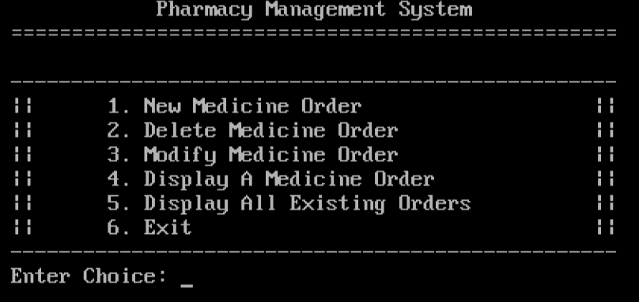
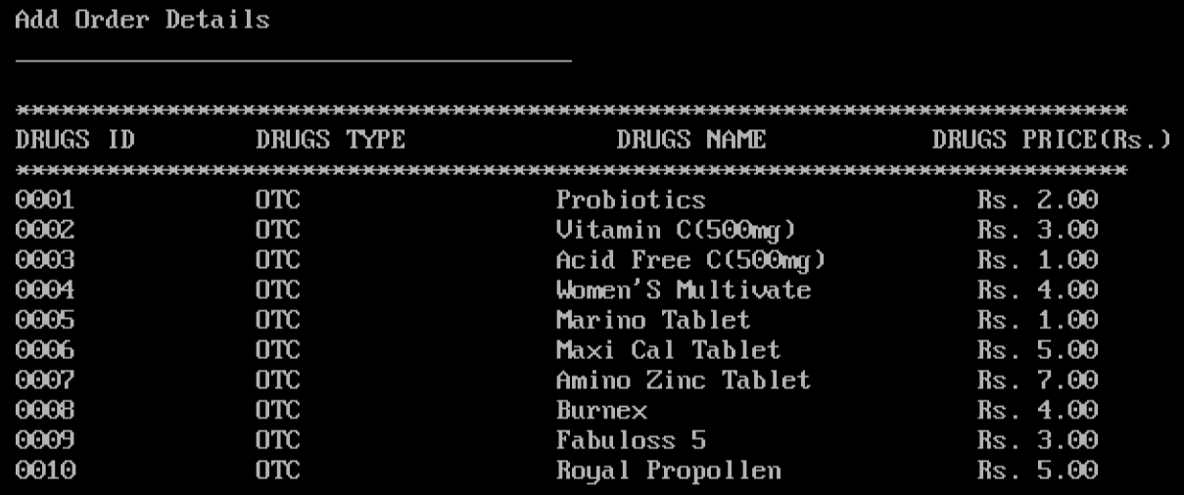

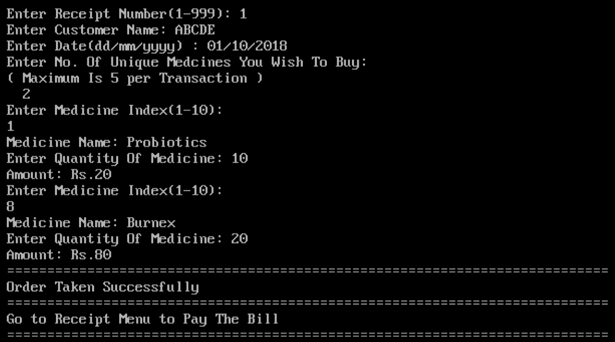
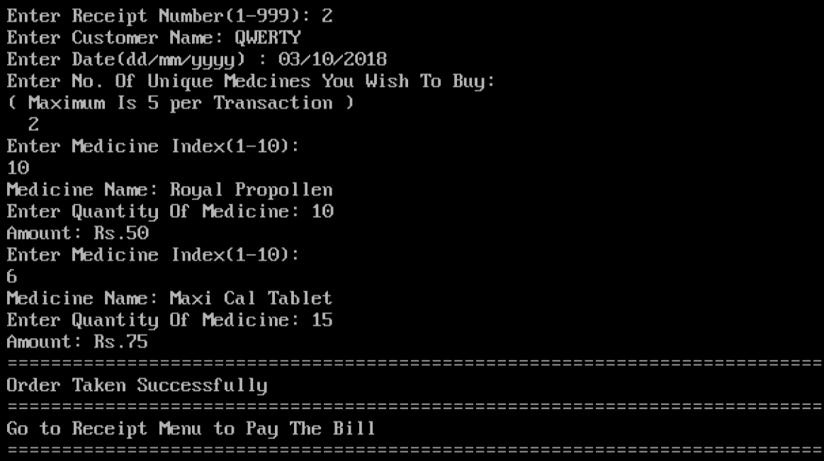

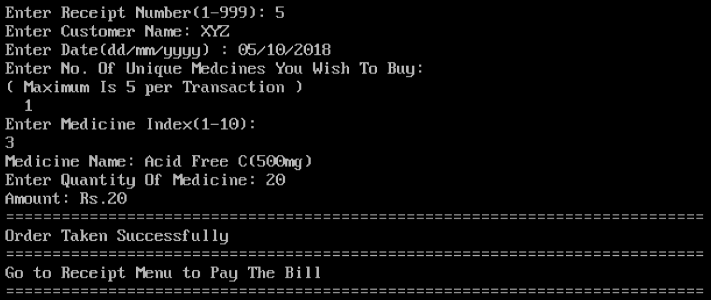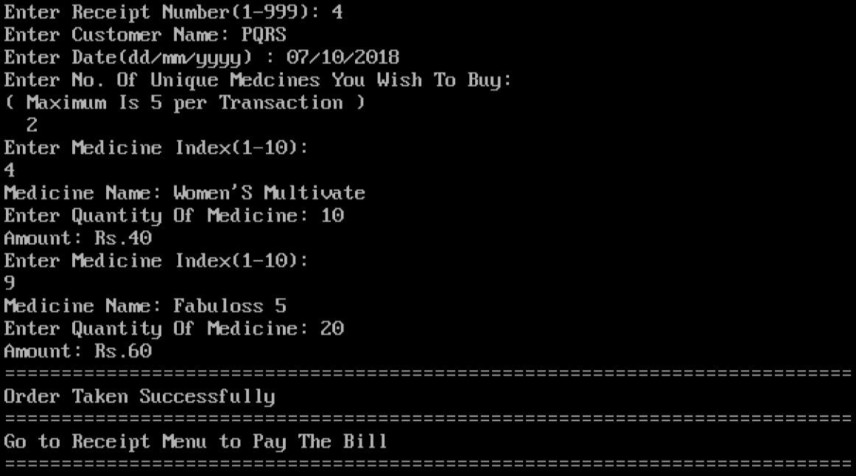

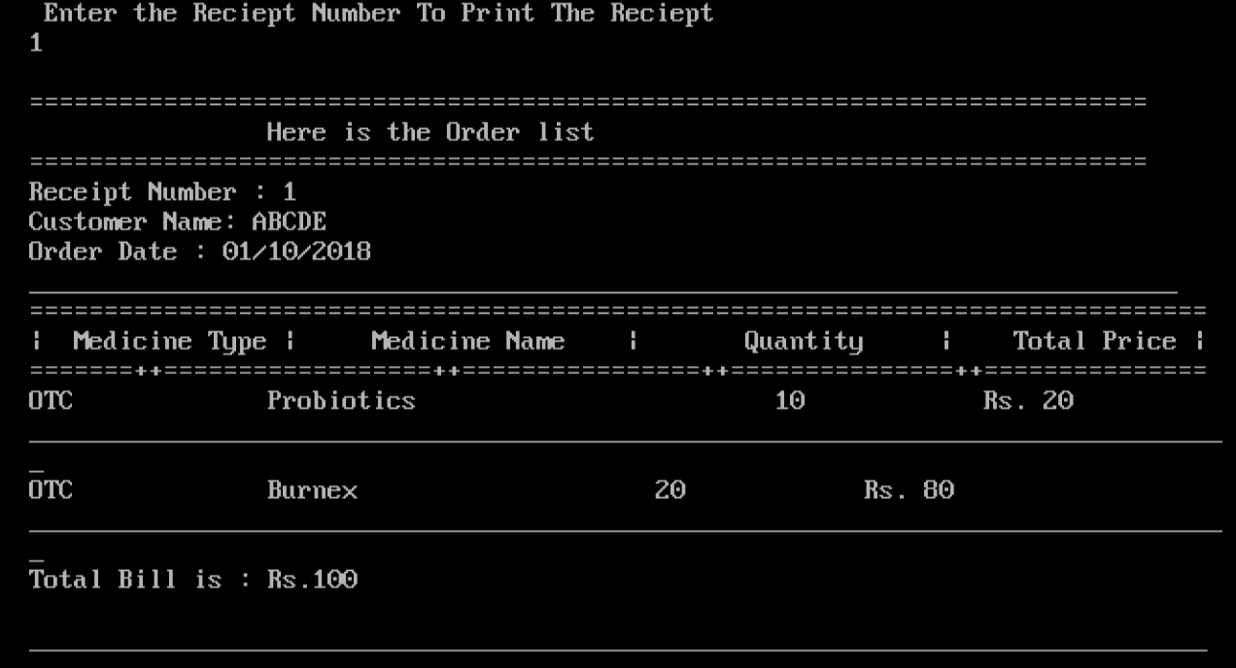
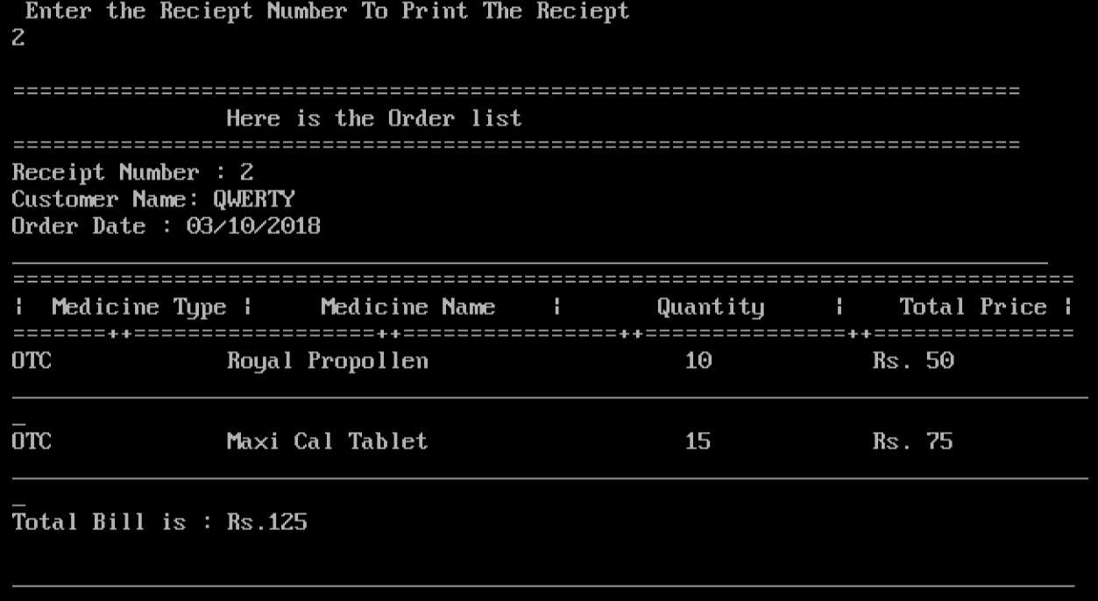

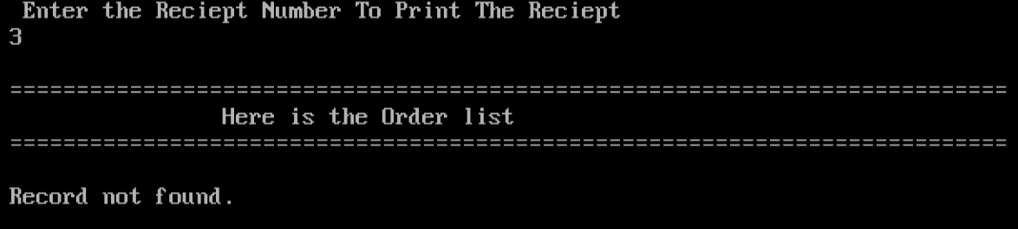
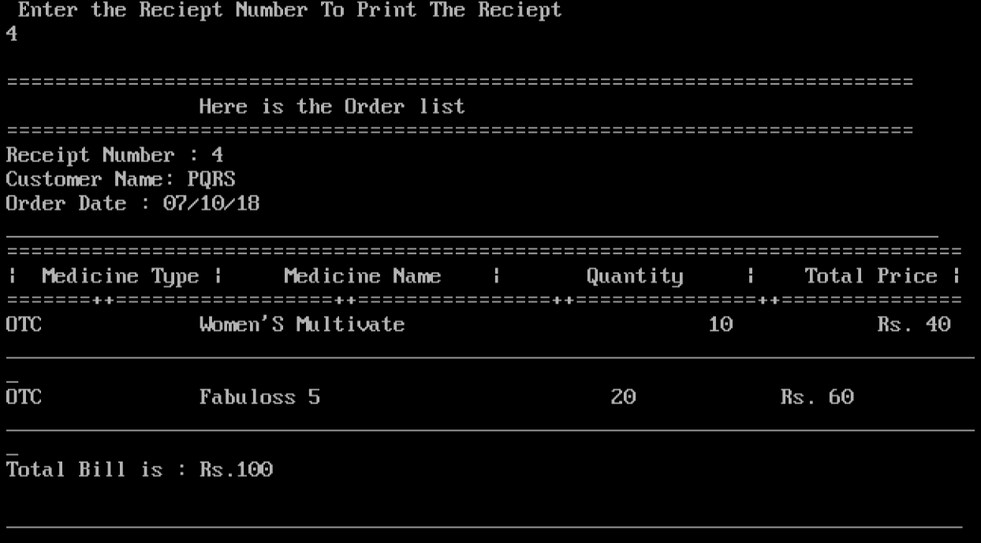
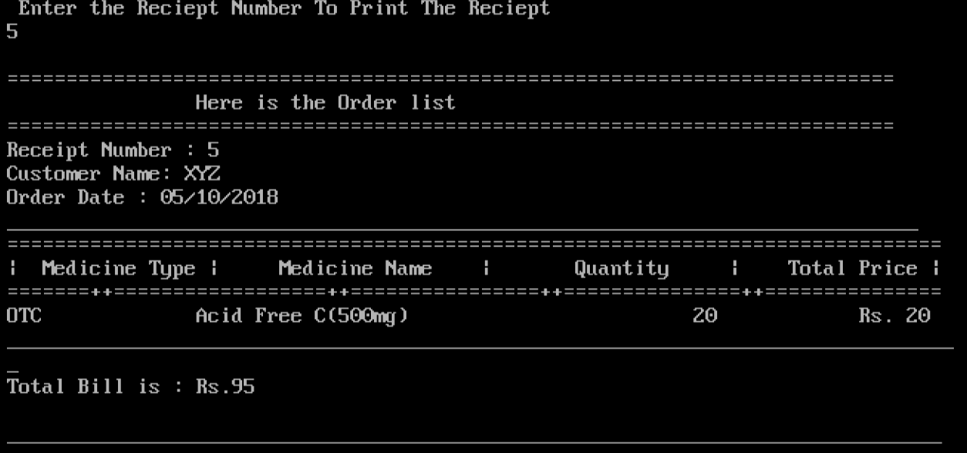

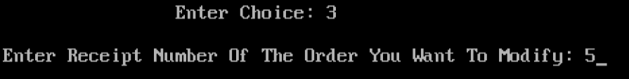
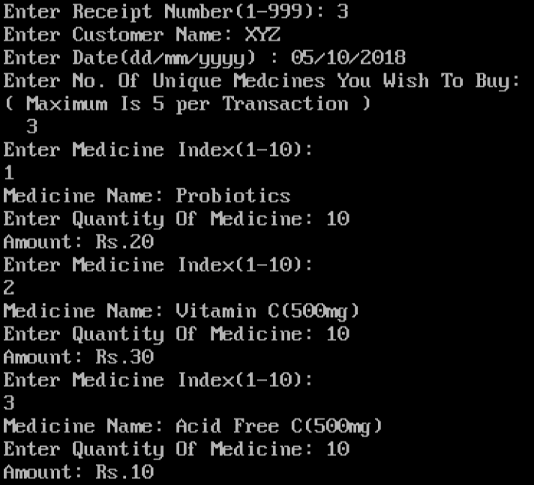

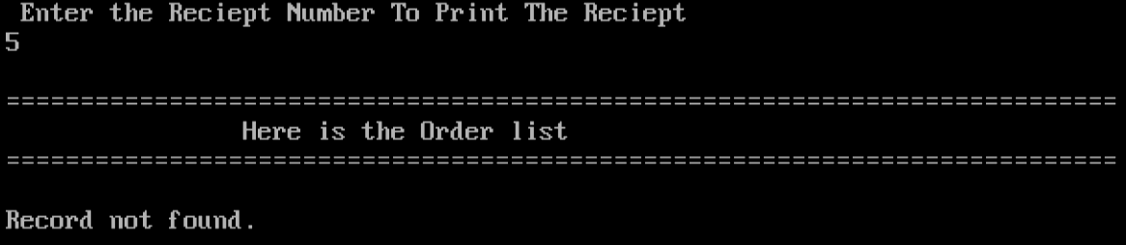
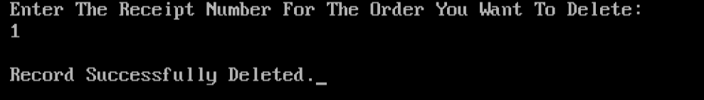

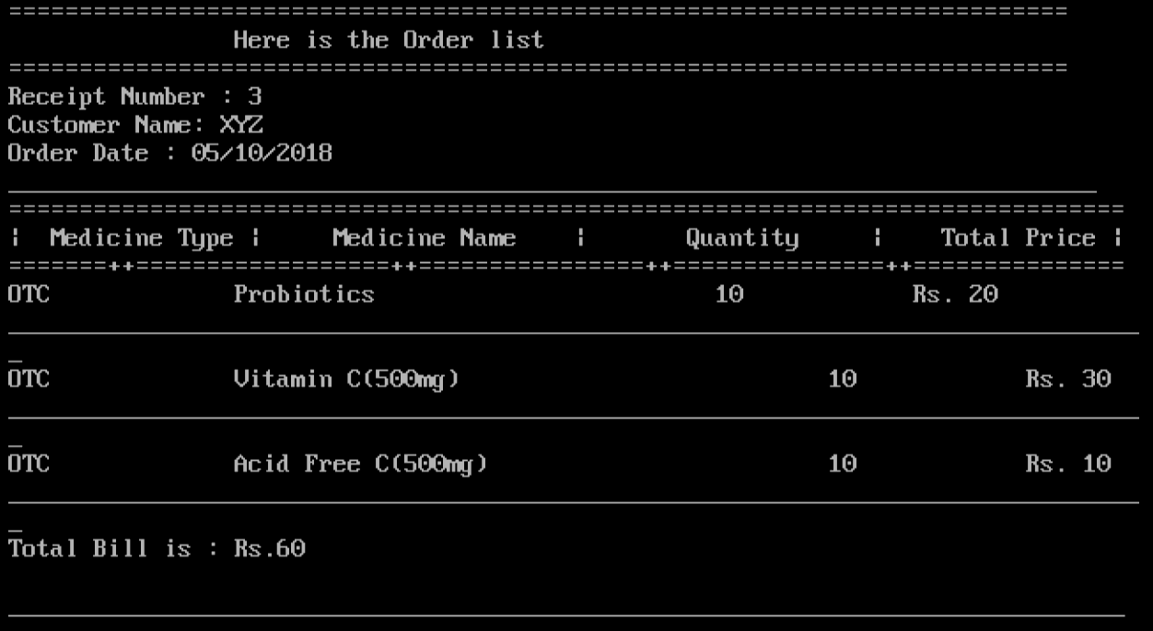
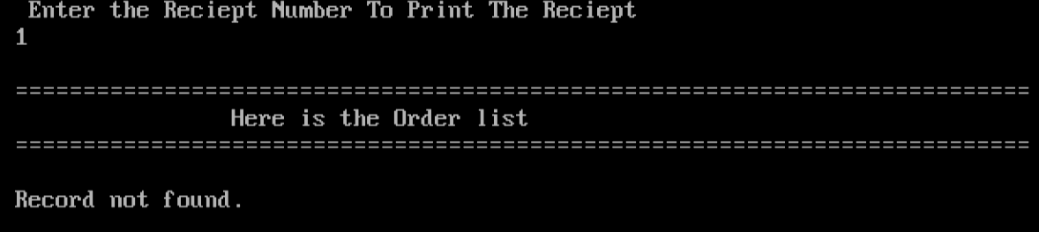

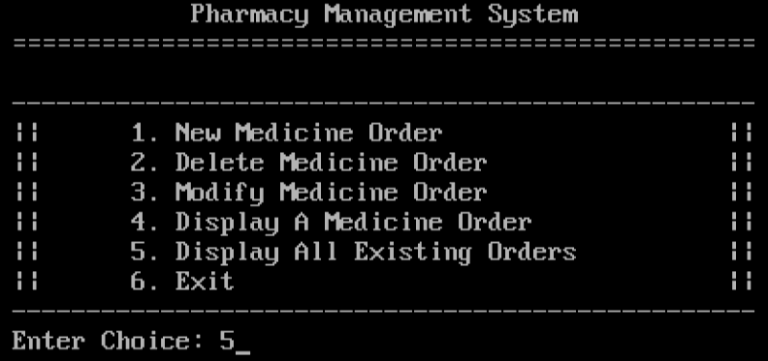
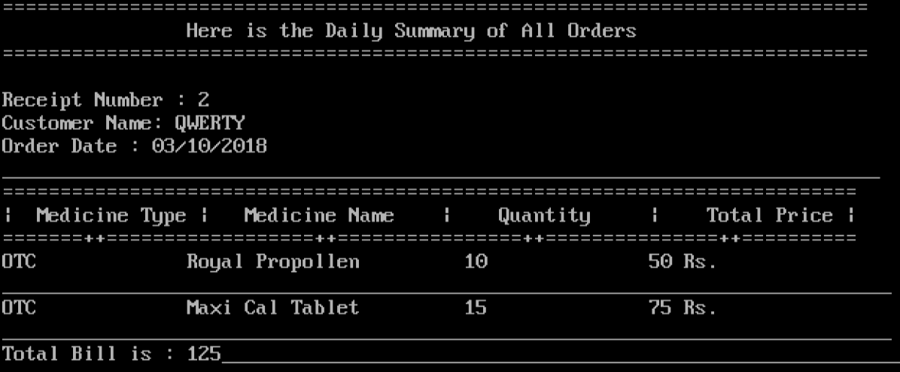

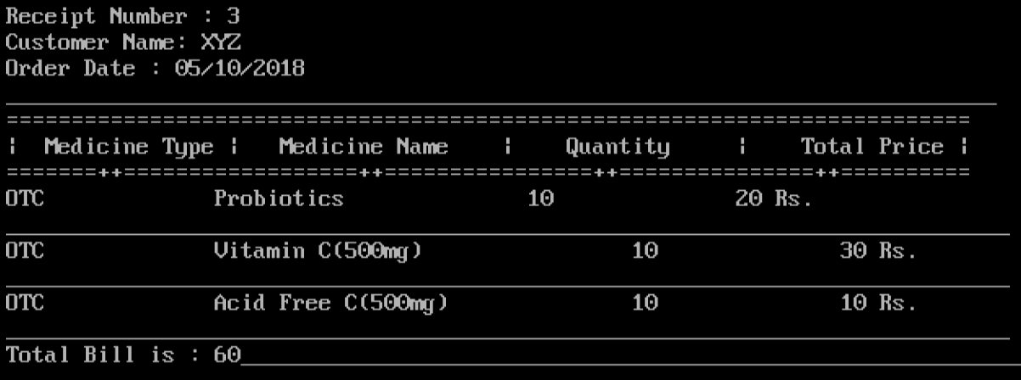
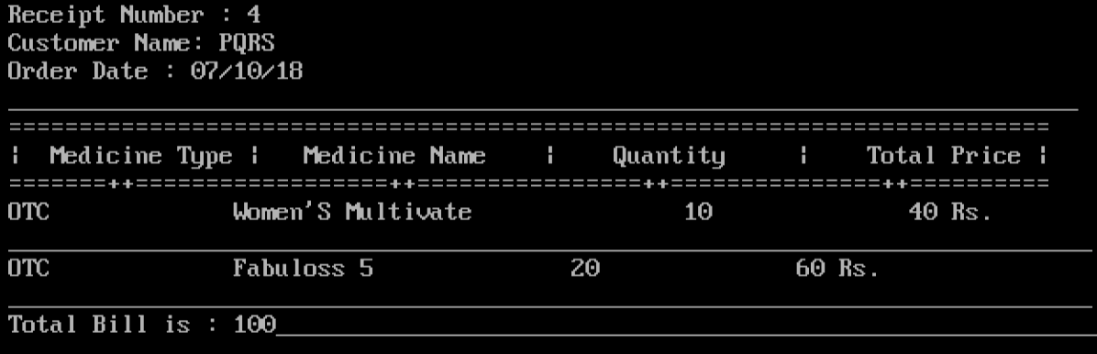

Scope of improvement:

We believe that striving for continuous improvement is better than hoping for perfection, hence here are some things that we feel we could improve upon or incorporate given more time and better resources:
- Keeping track of the available stock and displaying a message to alert the user of shortage of stock if required.
- Incorporating graphics to make the interface more colourful and appealing.
- Making the system more secure by accepting verification of authentication.
- Displaying change to be returned.

Bibliography:
Sumita Arora Class XII
Webliography:
code-projects.org


Acknowledgement

The acknowledgement is the most beautiful page of any book.
I, Badri M.S.V. of class XII, finds words inadequate to express my gratitude to many people. It is my privilege to express my gratitude to the Principal, Ms. Stella Pauline Punitha, for her valuable inputs and encouragement. I also express my gratitude to the Campus Head, Ms. Nancy James for her able guidance, whole hearted cooperation and constructive criticism throughout the duration of the project.
I would especially like to thank my Physics teacher, Dr. V. J. Chakravarthy for making the practical sessions both informative and enjoyable which motivated me to work towards my goals throughout the academic year 2018-19.
I would also like to thank the Lab Assistant, Mrs. N. Vasanthi, for assisting me with my experiments.
Last but not the least, I would like to thank my parents and friends for their consistent help and support.

Index
S. No. | Title | Page No.
1. | Introduction | 1
2. | Logic Gates | 2
3. | Boolean Algebra | 3
4. | Laws of Boolean Algebra | 4
 | 4.1 OR Laws | 4
 | 4.2 AND Laws | 5
 | 4.3 NOT Laws | 5
 | 4.4 Commutative Laws | 5
 | 4.5 De Morgan’s Theorem | 6
5. | Fundamental Logic Gates | 8
 | 5.1 OR Gate | 8
 | 5.2 AND Gate | 11
 | 5.3 NOT Gate | 14
6. | Combination of Fundamental Gates | 16
 | 6.1 NOR Gate | 16
 | 6.2 NAND Gate | 20
 | 6.3 EX-OR Gate | 22
7. | Experiment | 24
8. | Result | 26
9. | Bibliography | 27

